Date: 27/10/2026
Dr.ACS AURA 2026: 28th VTU Athletics Meet 2026

INSTITUTIONAL PROFILE AND ACHIEVEMENTS
1. About the Institution
Dr. ACS College of Engineering (Dr. ACSCE), Bengaluru, was established in 2009 under the aegis of the Moogambigai Charitable and Educational Trust, founded in 1992 by the visionary educationist Dr. A. C. Shanmugam. Moogamibigai Charitable and Educational Trust, was founded in 1992 with the main objective of Promoting Higher Education in Karnataka. Various professional institutions like Medical, Dental, Nursing institutions and functioning under the aegis of the Trust generally termed as RajaRajeswari Group of Institutions. RajaRajeswari Group of Institutions was established by our founder Chairman Dr.A.C.Shanmugam, B.A.LLB, FIMSA, FRCPS (Glasgow, UK), his pioneering vision and mission has contributed for the establishment of valued educational institutions. Dr.ACSCE was established in the year 2009. Chairperson’s motto is “To Create Job creators not job seekers”.
The institution was established with the objective of providing quality technical education and developing competent professionals who can contribute meaningfully to society, industry and national development. The Institution is located at Kambipura, Mysore Road, Bengaluru, the institution provides a conducive learning environment supported by modern infrastructure, qualified faculty members, well-equipped laboratories and facilities for academic, research and extracurricular activities. The college is Autonomous Institution under Visvesvaraya Technological University (VTU), Belagavi, and approved by the All India Council for Technical Education (AICTE), New Delhi.
The institution is committed to imparting holistic engineering education by integrating academic knowledge, practical skills, professional ethics, innovation, entrepreneurship and social responsibility. Its educational philosophy aligns with the vision of transforming students into technically competent professionals, innovative leaders and responsible citizens.
Vision
Engineering the future of the nation by transforming the students to be technically skilled managers, innovative leaders and environmentally receptive citizens.
Mission
To implement holistic approach in curriculum and pedagogy through Industry Integrated Interactions to meet the needs of Global Engineering Environment. To develop students with knowledge, attitude and skill of employability, entrepreneurship (Be Job creators than job seekers), research potential and professionally ethical citizens.

Institutional Core Values
- Academic Excellence :Commitment towards continuous improvement in teaching, learning, research, and professional development.
- Integrity :Maintaining ethical standards, transparency, and accountability in all institutional activities.
- Innovation :Encouraging creativity, research, and technology-driven solutions.
- Inclusiveness :Providing equal opportunities and a supportive learning environment.
- Sustainability :Promoting environmentally responsible practices and sustainable development.
- Leadership :Developing future-ready professionals with leadership capabilities.
- Professional Ethics :Building responsible engineers committed to societal welfare.
- Social Responsibility :Contributing towards community development and national progress.

2. Academic Programmes and Educational Excellence
Dr. ACSCE offers undergraduate and postgraduate programmes in diverse engineering and technology disciplines. The institution provides opportunities for students to develop interdisciplinary knowledge and competencies in conventional as well as emerging technological areas.
The major academic disciplines include:
- Aeronautical Engineering
- Aerospace Engineering
- Artificial Intelligence and Machine Learning
- Biomedical Engineering
- Computer Science and Engineering
- Computer Science and Engineering-Data Science
- Computer Science and Engineering-Cyber Security
- Computer Science and Engineering-IoT
- Electronics and Communication Engineering
- Mechanical Engineering
- Master of Computer Applications (MCA)
- Bachelor of Computer Applications (MCA)
- Postgraduate programmes in engineering disciplines.
The academic framework emphasizes Outcome-Based Education (OBE), continuous assessment, experiential learning, project-based learning and industry-oriented training. Students are encouraged to participate in technical competitions, seminars, workshops, internships, conferences and professional development programmes.
The institution strives to bridge the gap between theoretical knowledge and industrial requirements by providing practical exposure through advanced laboratories, technical clubs, industry interactions and collaborative activities.
3. Accreditation, Quality Assurance and Institutional Recognition
The institution has consistently focused on strengthening its academic standards through quality assurance, accreditation and continuous institutional development.
Major institutional recognitions include:
- NAAC Accreditation: The institution has secured an 'A' Grade accreditation from the National Assessment and Accreditation Council (NAAC).
- NBA Accreditation: The undergraduate Engineering programmes Aeronautical Engineering, Aerospace Engineering, Computer Science and Engineering, Electronics and Communication Engineering have received accreditation from the National Board of Accreditation (NBA), reflecting the institution's commitment to outcome-based education and programme quality.
- ISO Certification: The institution has pursued quality management practices through ISO certification.
- VTU Autonomous: All applicable engineering programmes operate under the academic framework of Visvesvaraya Technological University, Belagavi.
- AICTE Approval: The institution is approved by AICTE, New Delhi.
These recognitions reflect the institution's continuous efforts towards academic excellence, effective governance, quality teaching-learning practices and graduate employability.
4. Research, Innovation and Development
Research and innovation constitute important pillars of the institutional development strategy. Dr. ACSCE encourages faculty members and students to undertake interdisciplinary research, develop innovative solutions and contribute to emerging technological advancements.
The institution has established research facilities and VTU-recognised research centres across various engineering and science disciplines. These centres provide opportunities for doctoral research, postgraduate research, funded projects, publications, patents and collaborative research activities.
The institution has undertaken research initiatives in collaboration with government agencies, industries and research organisations. The research ecosystem promotes innovation in areas such as aerospace technology, defence applications, biomedical engineering, advanced materials, artificial intelligence, communication systems, renewable energy and computational engineering.
The institution's research and innovation initiatives include:
- Execution of externally funded research projects.
- Encouragement of faculty and student publications in reputed journals and conferences.
- Patent filing and intellectual property development.
- Organisation of national-level conferences, workshops and technical seminars.
- Promotion of interdisciplinary and industry-sponsored research.
- Development of innovative prototypes and technology-based solutions.
The institution's website highlights more than ₹1.75 crore in funded research projects, demonstrating its commitment to strengthening research and development activities.
5. Industry Collaboration and Skill Development
Dr. ACSCE strongly believes in industry-integrated education and maintaining close connections with industrial organisations, research institutions and professional bodies. The institution has established Memoranda of Understanding (MoUs) with industries and academic organisations to facilitate collaborative activities.
These collaborations support:
- Industrial visits and internships.
- Industry-oriented certification and value-added programmes.
- Faculty development and technical training.
- Expert lectures and industry interaction programmes.
- Collaborative projects and product development.
- Placement training and career guidance.
- Entrepreneurship development and startup initiatives.
The institution provides students with opportunities to participate in national-level technical competitions, innovation challenges and project exhibitions. Through these initiatives, students develop practical knowledge, teamwork, leadership and problem-solving capabilities.
The institution also promotes entrepreneurship through its Institution's Innovation Council (IIC), encouraging students to transform innovative ideas into viable products and business models.
6. Training, Placement and Career Development
The Training and Placement Cell play an important role in preparing students for professional careers. The institution provides structured training in aptitude, communication, technical skills, interview preparation and personality development.
Several reputed national and multinational organisations have participated in campus recruitment activities. The institution's placement network includes organisations such as Infosys, IBM, Capgemini, Tech Mahindra, Siemens, Robert Bosch, HPE and other leading companies.
The institution also facilitates internship opportunities, industry training, entrepreneurship initiatives and career guidance programmes to enhance students' employability.
As highlighted on the institutional website, Dr. ACSCE has recorded more than 554 placement offers, reflecting its continued efforts towards student career development.
7. Infrastructure and Learning Resources
The institution provides a comprehensive infrastructure to support academic excellence, research, innovation and student development.
Major facilities include:
- Modern classrooms equipped with ICT facilities.
- Department-specific laboratories and research facilities.
- Central library with digital learning resources, books and journals.
- Advanced computing facilities and high-speed internet connectivity.
- Seminar halls and conference facilities.
- Auditorium and convention facilities.
- Hostel and transportation facilities.
- Sports, recreation and student activity facilities.
The institution also encourages students to participate in cultural activities, sports, NSS, professional societies and technical clubs, ensuring their overall personality development.
8. Significant Institutional Achievements and Milestones
- Dr. ACSCE has achieved several milestones through its commitment to academic quality, research, innovation, industry engagement and student development.
- 100th Rank – DATAQUEST T-School Ranking 2026
- The institution announced its achievement of the 100th rank in the DATAQUEST T-School Ranking 2026.
- Top Engineering Colleges in Bangalore
- VTU Gold Medals and University Ranks – 2026
- Students secured outstanding positions in the 26th VTU Convocation, including first ranks in Aerospace Engineering and Biomedical Engineering, along with several other university ranks.
- Research and Funded Projects
- The institution has secured externally funded research projects exceeding ₹1.75 crore, supporting research infrastructure and innovation.
- Active participation in Smart India Hackathon, Institution's Innovation Council activities, startup promotion, project exhibitions and entrepreneurship development.
- Strong industry connections, 25 MoUs and more than 554 placement offers highlighted on the institutional website.
9. Institutional Development and Future Perspective
Dr. ACSCE continues to strengthen its position as a centre for quality technical education by focusing on emerging technologies, research excellence, industry collaboration and global academic engagement.
The institution aims to expand its Centres of Excellence, strengthen research infrastructure, promote innovation-driven education and increase opportunities for students to participate in national and international academic activities.
Special emphasis is placed on developing industry-ready graduates with multidisciplinary knowledge, entrepreneurial capabilities, professional ethics and lifelong learning skills. The institution also strives to strengthen collaborations with industries, research organisations, government agencies and international universities.
Through continuous improvement in academic processes, infrastructure, research activities and student support systems, Dr. ACSCE aims to contribute to India's technological growth and the development of skilled engineering professionals.
Dr. ACS College of Engineering, Bengaluru, stands committed to its founding philosophy of providing quality education and nurturing responsible professionals who can contribute to society and national development. Since its establishment in 2009, the institution has continued to strengthen its academic programmes, research capabilities, infrastructure, industry partnerships and student achievements.
Its focus on academic excellence, accreditation, funded research, innovation, entrepreneurship, placements and holistic student development reflects its commitment to building a strong foundation for future generations of engineers.
Dr. ACSCE remains dedicated to its motto of developing not merely job seekers, but job creators, innovative thinkers and responsible contributors to nation building.

10. Best Practices
- Adherence to Academic Calendar
- Training Students in Cutting-Edge Technology
- Methodologies to Support Weak Students and Encourage Bright Students
- Virtual classroom facility using Roombr ICT tools
- Career guidance Training
- Mandatory Internships in Industry
- Clean and Green Campus initiative
- Transforming Student Projects into Research Publications and Innovative Solutions

Management Hierarchy
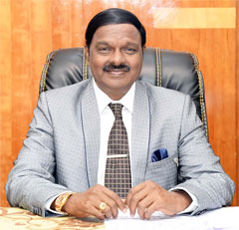
Dr.A.C.Shanmugam, B.A.LLB, FIMSA, FRCPS (Glasgow, UK)
Founder Chairman, RajaRajeswari Group of Institutions

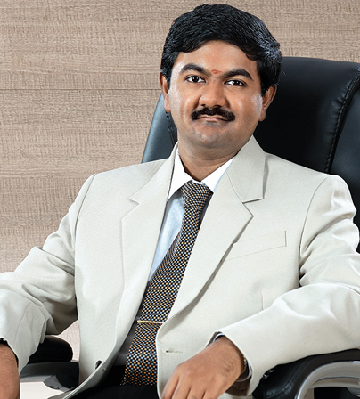
Sri A.C.S.Arunkumar B.Tech(Hons)., MBA,
President, RajaRajeswari Group of Institutions

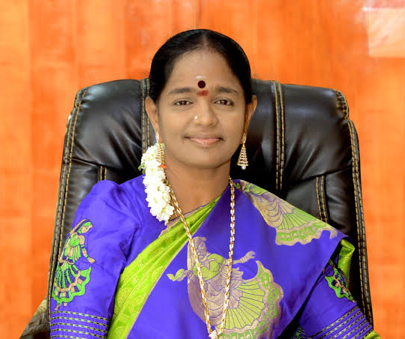
Smt. S. Lalitha Lakshmi
Chairperson, RajaRajeswari Group of Institutions

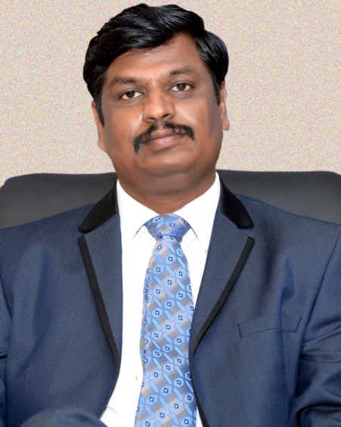
Dr.S.Vijayanand, M.Tech., Ph.D
Executive Director
RajaRajeswari Group of Institutions

Dr.S.JeyaBalan, M.Tech., Ph.D
Special Officer
RajaRajeswari Group of Institutions

Sri.C.N.Seetharam.,IAS(Retd.)
Chief Executive Officer
RajaRajeswari Group of Institutions

Dr.Meenakshi Sundaram
Registrar
RajaRajeswari Group of Institutions

Dr.A.K.Mariappan
Rector
RajaRajeswari Group of Institutions

Dr.B.S.Shylaja
Principal
Dr.ACS College of Engineering

VTU - UNIVERSITY RANK HOLDERS
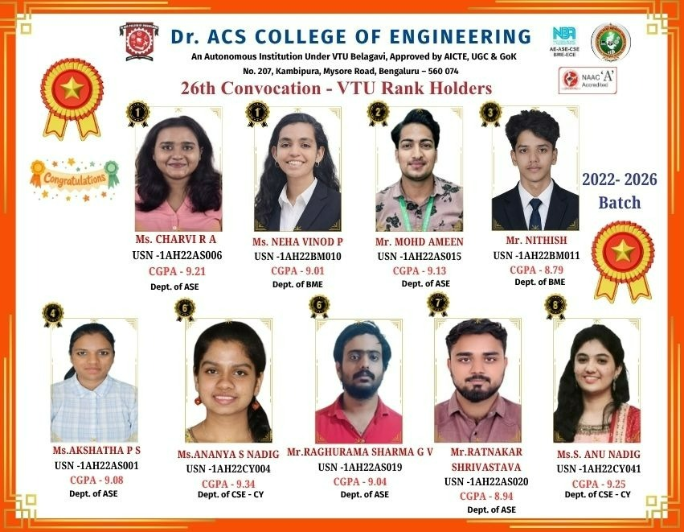
AY2024-2025
Department | Student Name | VTU Rank
2024-2025: Secured 10 VTU Ranks
Aeronautical Engineering | Balu S | 4th RANK
Aerospace Engineering | Saaket T N | 2nd RANK
Aerospace Engineering | Kandelwal Sujal Tapish | 3rd RANK
Aerospace Engineering | Banu K | 4th RANK
Aerospace Engineering | Ajay Rahul K | 5th RANK
Aerospace Engineering | Aishwarya A N | 6th RANK
Aerospace Engineering | Sangeetha B | 7th RANK
Biomedical Engineering | Harshitha M K (Gold Medal) | 1st RANK
Biomedical Engineering | Shirisha R | 4th RANK
Biomedical Engineering | Chaithra A | 5th RANK

AY 2023-2024
Department | Student Name | VTU Rank
2023-2024: Secured 07 Ranks
Aerospace Engineering | Poorvi M U (Gold Medal) | 1st Rank
Aerospace Engineering | Prajwal K | 2nd Rank
Aerospace Engineering | Pratheeksha M | 3rd Rank
Aerospace Engineering | Mohammad Iqbal | 4th Rank
Aerospace Engineering | Hrik Chakraborty | 5th Rank
Aerospace Engineering | Srujana C | 6th Rank
Biomedical Engineering | Linda Sunil | 4th Rank

AY 2022-2023
Department | Student Name | VTU Rank
2022-2023
2nd Top college in VTU with 12 Ranks
Aerospace Engineering | Riya D S ( 1 Gold Medal ) | 1st Rank
Aerospace Engineering | Veethasmi A Kumar | 2nd Rank
Aerospace Engineering | Spoorti G Bahaddurbandi | 3rd Rank
Aerospace Engineering | Sangeetha G | 4th Rank
Aerospace Engineering | Chandan Ganesh R | 6th Rank
Aerospace Engineering | Nanda Kumar R | 8th Rank
Aeronautical Engineering | Anju Jagadish | 8th Rank
Aeronautical Engineering | Syed Tayeeb Ahmed | 10th Rank
Biomedical Engineering | Indushree K P | 2nd Rank
Biomedical Engineering | Vaishnavi B | 5th Rank
Biomedical Engineering | Basavaraj V | 6th Rank
Biomedical Engineering | Likitha M | 7th Rank

AY 2021-2022
Department | Student Name | VTU Rank
2021-2022
2nd Top college in VTU with 12 Ranks
Aerospace Engineering | Swetha Shree ( 1 Gold Medal ) | 1st Rank
Aerospace Engineering | Vidya Kumari M N | 3rd Rank
Aerospace Engineering | Nithyasri BS | 4th Rank
Aerospace Engineering | Varshith R Shetty | 5th Rank
Aerospace Engineering | Srinidhi N S | 6th Rank
Aerospace Engineering | Nagaraja M V | 7th Rank
Aerospace Engineering | Priyanka L P | 8th Rank
Electronics and Communication Engineering | Swathi S ( 7 Gold Medals ) | 1st Rank
Biomedical Engineering | Prathiksha K | 3rd Rank
Biomedical Engineering | Deepthi B | 7th Rank
Biomedical Engineering | Priya K R | 9th Rank
Aeronautical Engineering | Swikruti S Davande | 8th Rank

Year | Department | Student Name | VTU Rank
2020-2021 | Aerospace Engineering | Chandu.C P (1Gold Medal) | 1st Rank
2020-2021 | Aerospace Engineering | Ajay Yalameli | 2nd Rank
2020-2021 | Aerospace Engineering | Dhansingh Bhandari J | 3rd Rank
2020-2021 | Aeronautical Engineering | Niveditha R | 7th Rank
2020-2021 | Biomedical Engineering | Noorena A | 3rd Rank
2020-2021 | Biomedical Engineering | R Navya Sree | 5th Rank
2020-2021 | Biomedical Engineering | Kavya S.N | 7th Rank
2020-2021 | Biomedical Engineering | Rashmi S | 9th Rank
2020-2021 | Biomedical Engineering | Ananya M | 10thRank
2019-2020 | Aeronautical Engineering | Shaheen shaikh | 8th Rank
2019-2020 | Biomedical Engineering | Susmitha Katti | 9th Rank
2018-2019 | Aeronautical Engineering | Naveen V | 4th Rank
2018-2019 | Biomedical Engineering | Ragavi A R | 8th Rank

